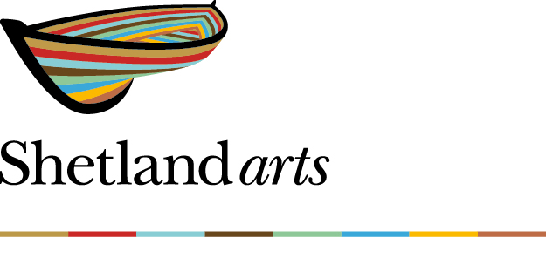

Impact Report
April – September 2025

This report summarises Shetland Arts’ progress towards delivering its Social Outcomes during the first six months of 2025–26, drawing on departmental reports, audience feedback, and public engagement activity.

1. Improved quality of life through greater access to creative and social experiences
Alignment with Shetland Charitable Trust Goals - Community wellbeing; Individual wellbeing; Everyone matters; Generational fairness

Key Performance Indicators April – September 2025
Performances, Screenings, Exhibition Days – 1,480
Audience Attendances – 90,166
The audience at Homemade Saturday 6 September. 33 short films, under 4 mins, were screened. Christie Tulloch (aged 12) won the audience award for “Zombies - A Lego Stop Motion”, Josiah Naquin (aged 17) won the judges award for “A Matter of Faith” and Islesburgh Photographic Club won the Shetland Forwirds sponsored dialect award for “Da Boat Biggir’s Nefjoo”.
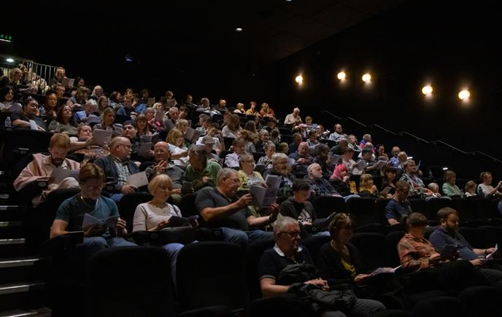

Between April and September 2025, Shetland Arts presented an extensive range of performances, screenings, and exhibitions that strengthened social connection and cultural participation across the islands. Highlights included the student exhibition ‘The Two Contrasting Views from Mary’s House’ by UHI Fine Art student Millie Wishart and the ‘Second Chances’ exhibition delivered in collaboration with Shetland Islands Council’s Community Justice programme. Public feedback praised these projects for creating inclusive, thought-provoking experiences, one visitor described the latter as “an important reminder of how creativity supports recovery and belonging.” Shetland Arts facilitated over 200 events, from concerts to community gatherings, and supported the Shetland Young Promoters Group’s first Under-10s concert, encouraging younger audiences to engage with live music.
Feedback from audience surveys reflected a 92% satisfaction rate, with common themes including appreciation for the “friendly atmosphere,” “great value,” and “varied programme.”
Blog posts over the period documented the vibrancy of programming, with posts such as ‘June Films On Sale Now!’ and ‘Lee Child Announced as First Headliner for Shetland Noir 2026’ reaching more than 5,000 online readers, helping maintain momentum and awareness of local creative life.
“It’s great to have access to this kind of art and performance without needing to leave the islands.”
“Lovely to see such varied artwork on the wall – it makes the space feel open and welcoming.”
“I loved being part of something local that still felt world-class.”
“Being able to go to events like this regularly makes Shetland feel vibrant and connected.”

2. Improved opportunities through the development of new skills
Alignment with Shetland Charitable Trust Goals - Individual wellbeing; Generational fairness

Key Performance Indicators April – September 2025
Development Sessions – 264
Participations – 1,498

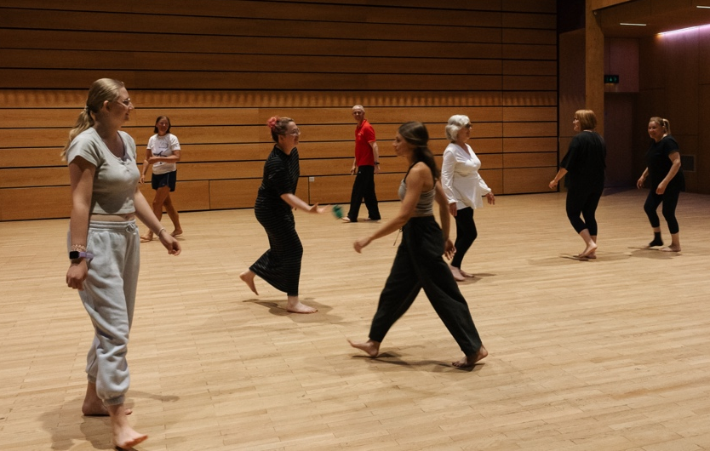
Garbanzo physical theatre workshop delivered by Emily Briggs 20 July 2025. Emily, along with collaborator Andreia Simões, spent two weeks in Mareel developing her one-woman show Garbanzo. The residency provided time to develop the show, and the opportunity to share their creation practises by facilitating two community workshops.
cnmm

Education and Learning programmes continued to nurture creative talent at all stages. Skills for Work and Senior Phase pupils achieved key learning outcomes in Creative Industries and Employability awards, while degree and postgraduate students based at Mareel completed graded units and digital portfolios.
The student showcase at Mareel in June drew an enthusiastic audience of families and peers; one attendee commented, “The students’ confidence and professionalism were inspiring.”
Creative Shetland Commissioning Fund supported professional growth for artists including Ruth Oliver and Liz Musser (Story Slam development), Lydia Hann (community textile workshops across Unst and Voxter), and Emily Briggs (Garbanzo performance residency). Additional training was delivered in cinema operations and live event delivery, enhancing Shetland Arts’ organisational resilience.
Overall, more than 500 individuals participated in workshops or training activity during this period, with 97% of respondents reporting increased skills or creative confidence.
“Workshops helped me learn new skills and meet others who share my interests.”
“The students’ confidence and professionalism were inspiring.”
“I didn’t think I could do this kind of creative work before joining the sessions – now I can.”
“The residency gave me space to experiment and grow as an artist.”

3. Improved confidence to contribute positively through greater opportunities for self-expression and community involvement
Alignment with Shetland Charitable Trust Goals - Individual wellbeing; Generational fairness

Key Performance Indicators April – September 2025
Development Sessions – 264
Participations – 1,498
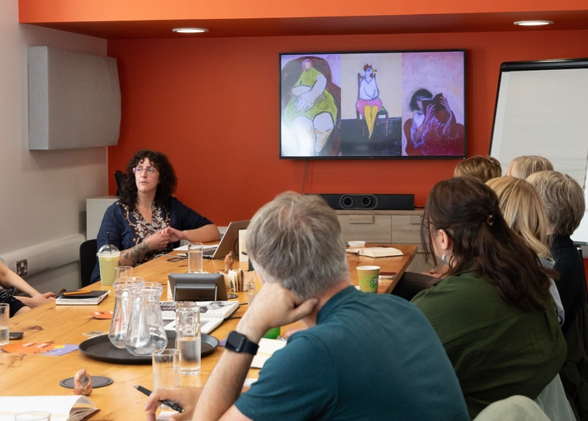
Susan Pearson presenting at an artists meet up on the 26 September. These informal gatherings, aimed at local creative practitioners, to share their practice, connect, learn from one another. Each session features a 20-minute informal presentation by one guest artist about their work. After the presentation there is a facilitated discussion/group conversation, referencing the presentation’s themes.

.

Empowerment through creativity remained a core thread across the six months. VACMA recipients advanced diverse personal projects, Fionn Arnett invested in equipment to expand his sculptural work, Chris Smith experimented with seaweed-based film development, and Chloe Tallack explored video projection for her upcoming Soup and a Show appearance.
Shetland Youth Theatre resumed weekly workshops for ages 11–25, fostering expressive confidence through devised performance and storytelling. Audience feedback described events as “uplifting” and “a reminder of what community creativity can achieve.”
Community participation also thrived through initiatives such as Mareel’s Artist Meet-Ups, encouraging peer learning and collaboration among local creatives. This nurturing environment has seen participants increasingly self-organising new projects, a sign of sustained empowerment.
“It’s nice to share my work in a public place after having it hidden away in the studio – it’s given me a confidence boost.”
“Performing here made me feel part of something bigger – like my work mattered.”
“Thank you for making this happen – it was a reminder of what community creativity can achieve.”
“I felt included and inspired to try something new.”

4. Improved feeling of inclusion and equality through an appreciation of a diversity of cultures and lifestyles
Alignment with Shetland Charitable Trust Goals - Community wellbeing; Individual wellbeing; Everyone matters; Generational fairness

Key Performance Indicators April – September 2025
Performances, Screenings, Exhibition Days – 1,480
Audience Attendances – 90,166
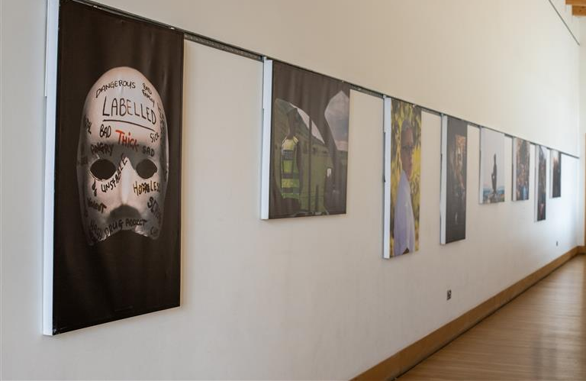
Working in collaboration with Shetland Islands Council and Community Justice Scotland, we presented Second Chances. An exhibition that offers a poignant look at how people who have offended can be offered “second chances”, and how community-based sentencing and reintegration can play a role.
.

Shetland Arts maintained its commitment to inclusion, delivering activities that celebrated diverse voices and promoted access for all. Helen Robertson’s ‘Knit Your Own Bee’ workshops welcomed first-time knitters and experienced makers alike, contributing to her large-scale community installation ‘Ultimate ThulBEE’.
Emily Briggs delivered physical theatre and movement workshops for both school-age participants and adults, using mime and dance to explore identity and connection. Public comments highlighted the value of these events, “I felt included and inspired to try something new.”
The Access and Inclusion Group continued its quarterly meetings, focusing on accessibility of information and physical design. While feedback was overwhelmingly positive, some survey comments suggested improving signposting and temperature comfort at venues, both now incorporated into ongoing improvements.
“Everyone’s voice is welcome in the circle – we were a complete mix of people and it was wonderful.”
“Events like this make Shetland feel more inclusive and open to different perspectives.”
“Lovely to see art that represents different cultures and experiences.”
“The staff were welcoming and made sure everyone could participate, whatever their ability.”

5. Improved mental and physical health through more active involvement in creative and social experiences
Alignment with Shetland Charitable Trust Goals - Individual wellbeing; Everyone matters

Key Performance Indicators April – September 2025
Development Sessions – 264
Participations – 1,498

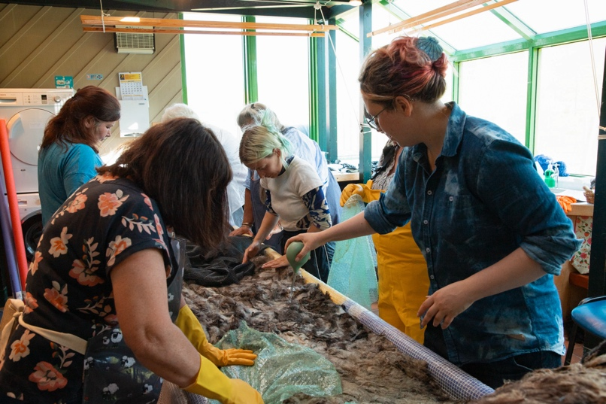
FELT workshop delivered by Lydia May Hann on 30 July. FELT is a workshop & exhibition project building upon work previously undertaken in Norway. FELT is a meeting point between material, heritage and people through the medium of unprocessed sheep's fleece. The exhibition is available to view in Mareel until 30 November.
.

Creativity continued to serve as a catalyst for wellbeing. The ‘Remembering Together’ COVID Memorial project launched publicly in May, combining art, writing, and film to commemorate shared experiences of the pandemic. Participants described the process as “healing” and “deeply meaningful.”
In partnership with national networks, local artist Suzanne Briggs undertook Singing Mamas training, preparing to lead inclusive singing sessions for women. Early feedback from pilot sessions suggested a strong sense of connection and relaxation among attendees.
Across all programmes, creative participation supported wellbeing—95% of feedback respondents reported feeling happier or more connected after attending events. The consistent message from audience feedback, “Well done Shetland Arts for bringing this”, illustrates the sustained importance of arts for emotional health.
“The singing group has become part of my weekly routine – I always leave feeling lighter.”
“It’s just so good for the soul – I came in tired and left smiling.”
“Taking part helped me through a tough time – it gave me focus and calm.”
“We are singing for now, for ourselves and for each other – it’s joy in the moment.”

6. Improved community resilience through a more diverse creative economy
Alignment with Shetland Charitable Trust Goals - Community wellbeing

Key Performance Indicators April – September 2025
Practitioners and Micro Businesses Supported – 475

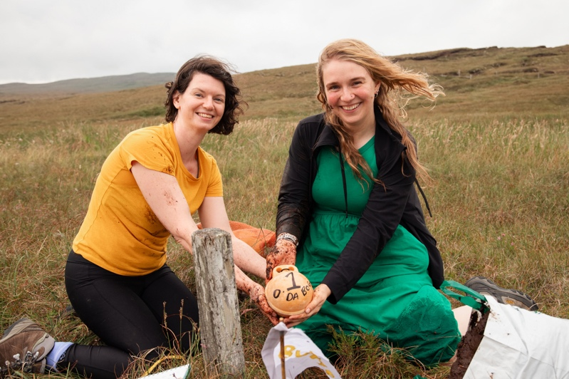
O' Da Bog, Aidan Nicol & Jenny Watt taken on a research trip on 18 July. ‘O Da Bog’ is an edible art, film and science collaboration offering a visually exciting, approachable and interactive experience of the cultural and environmentally significant features of blanket bog. The installation will take place at Hymhus on 29 – 31 November.
.

The creative economy was strengthened through multiple initiatives supporting local practitioners. The provision of affordable studio space and technical support for musicians, filmmakers, and artisans, enabling new commercial releases and exhibitions.
The quarterly Arts and Crafts Fair continued to showcase local talent and stimulate the visitor economy. Commissioning and residency projects underpinned freelance sustainability, including ‘Even Here, Even Now,’ where Shetland artists collaborated with peers from Orkney and the Outer Hebrides to develop new island-inspired work. A blog post in August celebrated these networks as “proof that distance need not limit collaboration.” Creative practitioners increasingly note that Shetland Arts provides both a professional platform and a reliable creative community, key ingredients in long-term sector resilience.
“It’s brilliant to see local artists supported – it makes a huge difference to us staying here.”
“The creative economy here feels alive again – there’s collaboration and opportunity everywhere.”
“Having a space to record and exhibit means I can sustain my work in Shetland.”
“I’ve started selling my work because of the visibility this gave me – that’s life-changing.”

Context, Challenges and Learning
While overall engagement and satisfaction remain high, external pressures, particularly rising operational costs and course recruitment challenges, have required flexibility and innovation. Adapting educational delivery to focus on degree-level contextual tutoring has maintained learning continuity and strengthened local academic relevance. Feedback continues to guide improvement, with enhanced communication and accessibility already prioritised for the next quarter.
Staff recruitment is a mixed bag. Some rolls are significantly over subscribed, 74 applications for the role of Director of Creativity and Impact, demonstrate the national and international reputation of the organisation. However, we are not immune to the ongoing challenges of the hospitality sector in Shetland and the business model for the café bar at Mareel is under review.
The support of the Shetland Charitable Trust Capital Grants scheme has seen the following projects continue in the period:
- Bonhoga refurbishment works (to be completed January 2026)
- Mareel Changing Places Toilet (Works to start on site 10 November 2025)
- Mareel Emergency lighting replacements planning
The building work at Bonhoga continues to progress and regular blog posts are well received. A recent survey seeking input on reopening plans has over 300 responses.
The first six months of 2025–26 have shown how Shetland Arts’ blend of creativity, community partnership, and practical support delivers tangible outcomes aligned with Shetland Charitable Trust’s strategic goals.

